LAB221 Assignment | Type: | Short Assignment
 | Code: | J2.S.P0114
 | LOC: | 70
 | Slot(s): | 2

Title
Create database
Background Context
NA

Program Specifications
Use swing library to create a program interact with MS SQL database.
Main functions described as below:

Function details:

- Create a new database name “FU_DB”
- Create a table name “Stocks” with fields:
- StockID: type is integer
- StockName: string
- Address: string
- DateAvailable: Date
- Note: string
- Insert into “Stocks” table 5 records
- Display all 5 records on the form
Expectation of User interface:
The screen should be as:

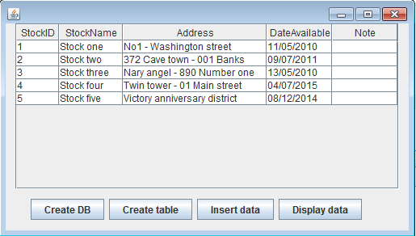

Guidelines

